Mashpee Recreation Vacation Club

Join us for a fun-filled day, and bowling @ The Lanes!
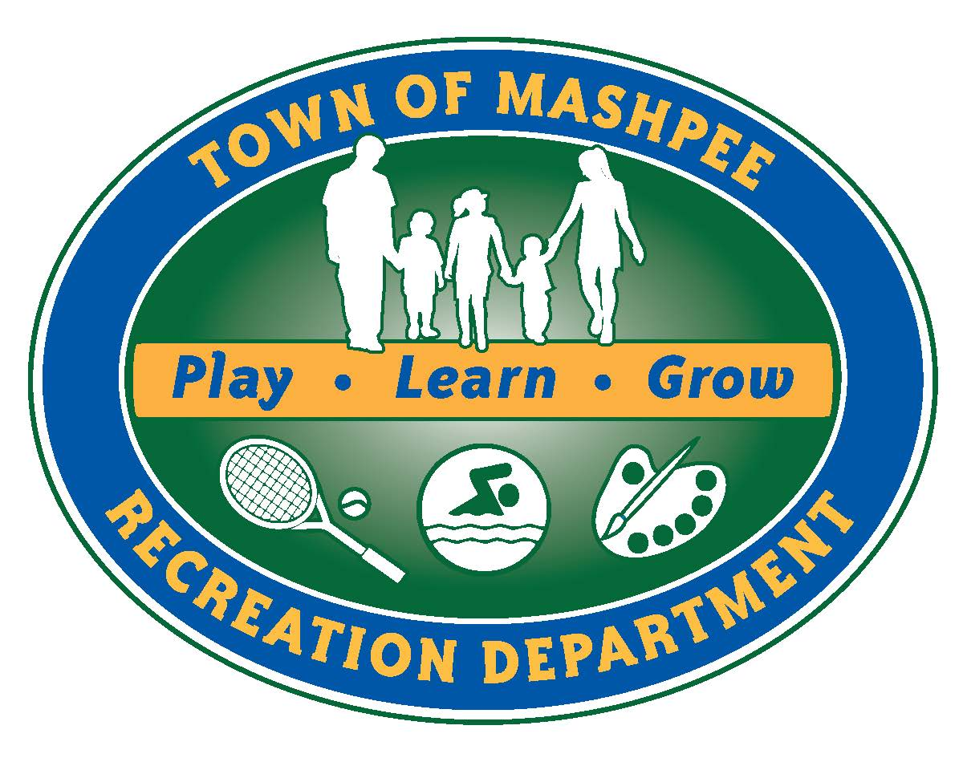
Friday, September 4, 2015
Join the Mashpee Recreation Staff in a fun day of games and activities! We will be taking a walking trip to The Lanes Bowl & Bistro in the Mashpee Commons for some bowling fun!

Grades: K-6
Location: K.C.Coombs School
Drop Off- 7:00am Pick up- 5:30pm

Depart school- 10:00
Return to school- approximately 12:30

Children should bring a lunch, 2 snacks, and a drink. They should dress appropriately for the weather.

Recreation Office: 508-539-1416

To Register:

Online: www.mashpeerec.com

In Person: Recreation Department at Town Hall

By Fax: 508-477-0497

By Mail: Mashpee Recreation Department
16 Great Neck Rd. N.
Mashpee, MA 02649
(Checks payable to “Town of Mashpee”)

--------------------------------------------------------------------------------------------------------------------------------------------
Registration Fee: $30 **No Refunds**
Space is limited…Register Early!

HOLD HARMLESS CLAUSE: I, the undersigned parent/guardian or participant, do hereby consent to my/their participation in voluntary athletic, recreation, or community education programs of the Town/City, or Public School of Mashpee.
I also agree to forever release the Town/City of Mashpee, the School Committee, and all their employees, agents, board members, volunteers and any and all individuals and organizations assisting or participating in voluntary athletic, recreation, or community education programs of the Town/City or Public Schools (“the Releases”) from any and all claims, rights of action and causes of action that may have arisen in the past, or may arise in the future, directly or indirectly, from personal injuries to my child or property damage resulting from my child’s participation in the Town or Public School of Mashpee voluntary athletic, recreation, or community education programs.
I also promise, to indemnify, defend, and hold harmless the Releases against any and all legal claims and proceedings of any description that may have been asserted in the past, or may be asserted in the future, directly or indirectly, arising from personal injuries to my child or property damage resulting from my participation, or my child’s participation in the Town/City or Public School of Mashpee voluntary athletic, recreation, or community education programs.
I further affirm that I have read this Consent and Release Form and that I understand the contents of this Form. I understand that my participation, or my child’s participation in these programs is voluntary and that my child and I are free to choose not to participate in said programs. By signing this form, I affirm that I have decided to allow my participation, or my child’s participation in the Town/City or Public School’s athletic, recreation, or community education programs with full knowledge that the Releases will not be liable to anyone for personal injuries and property damage my child or I may suffer in voluntary Town/City or Public School athletic, recreation, or community education programs.

Print Name:_________________________________________________________

Signature:____________________________________ Date___________________

Name of Participant:____________________________________

Address:__________________________________________________

City/State/Zip:___________________________________________

DOB:_____________Age:_______Grade:_______Gender:_____

Medical Conditions/Allergies:___________________________________

Parent’s Name:__________________________________________

Cell #:________________________Carrier:___________________

Home#:_____________________Email:______________________

Emergency Contact:_____________________________________

Emergency Contact Phone:____________________________________________________

Cash_________ Check #__________Credit Card(below)

MC/VISA # __ __ __ __ __ __ __ __ __ __ __ __ __ __ __ __

Exp __ __ / __ __ 3 Digit Code ___ ___ ___

